វិទ្យាស្ថានបច្ចេកវិទ្យាកម្ពុជា

Institute of Technology of Cambodia

Department of Information and Communication



Subject: Internet Programming

Professor: HOK TIN

Assignment: TP10

Name: LAY Vicha

ID: e20190494

Group: I4-GIC-B

2022-2023

Contents

1. Git url : https://github.com/LAY-VICHA/TP_IP_year4/tree/main/TP10 1

2. EX1 – Connect node project to Mongodb 1

3. EX2 – add more API to node project (me, update password, user, delete) 3

# Git url : https://github.com/LAY-VICHA/TP_IP_year4/tree/main/TP10

# EX1 – Connect node project to Mongodb

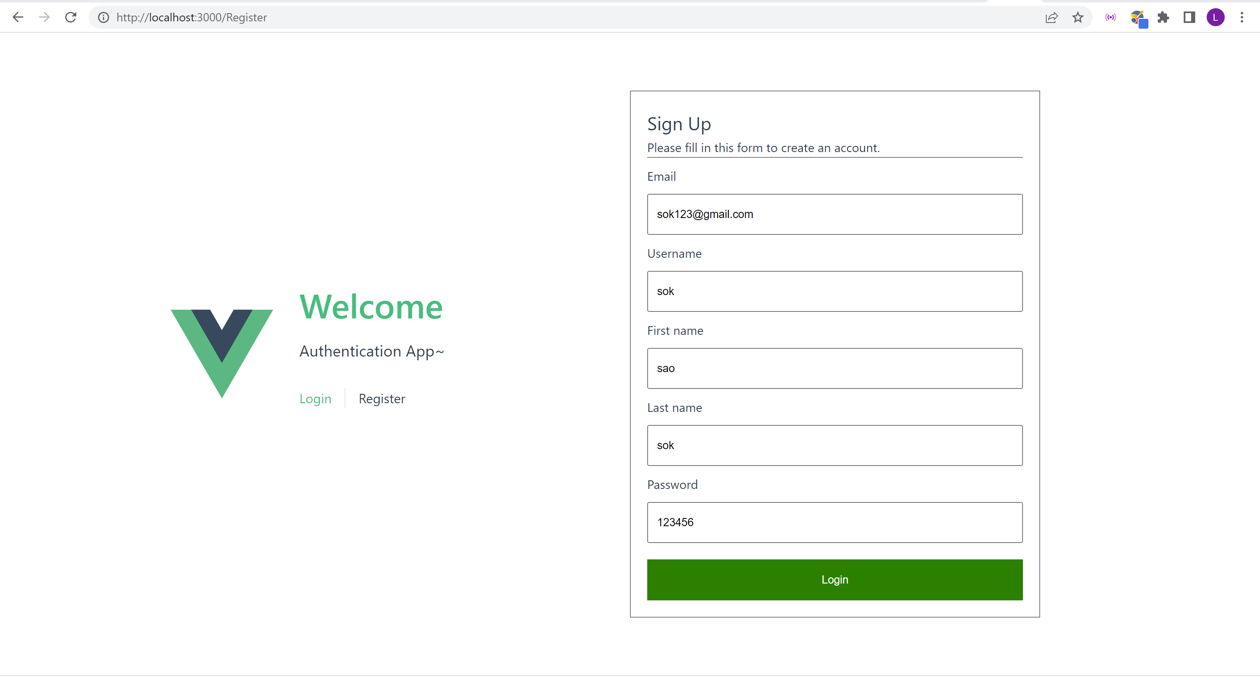

* After register, our application will route to login page

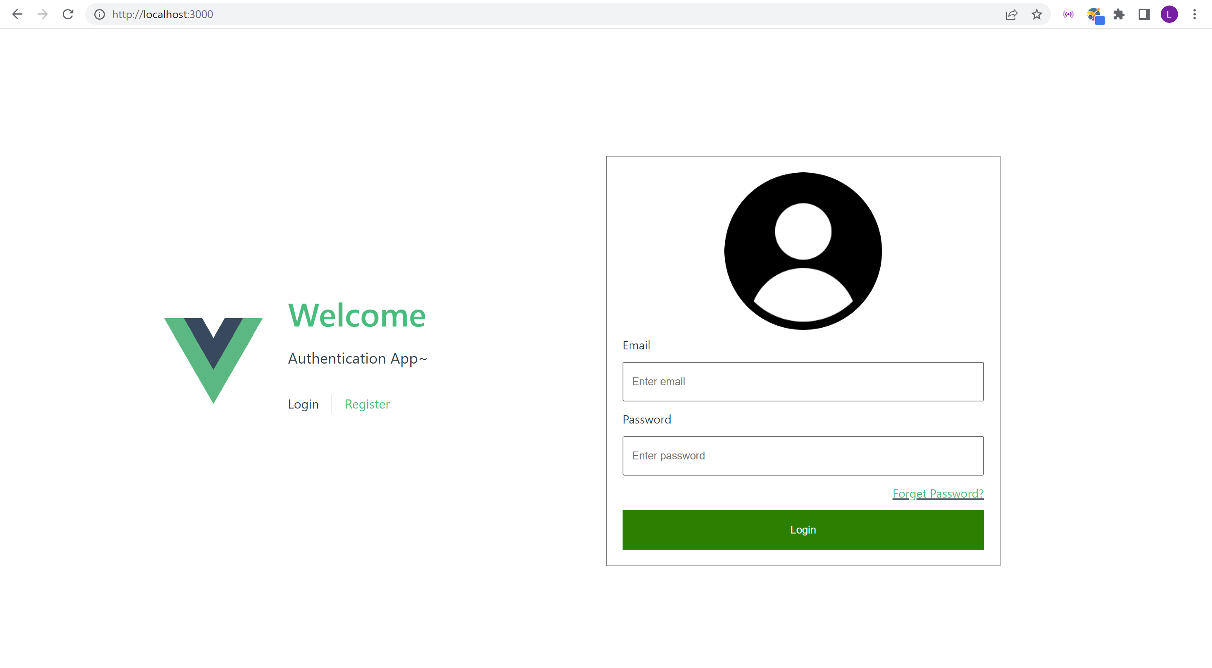

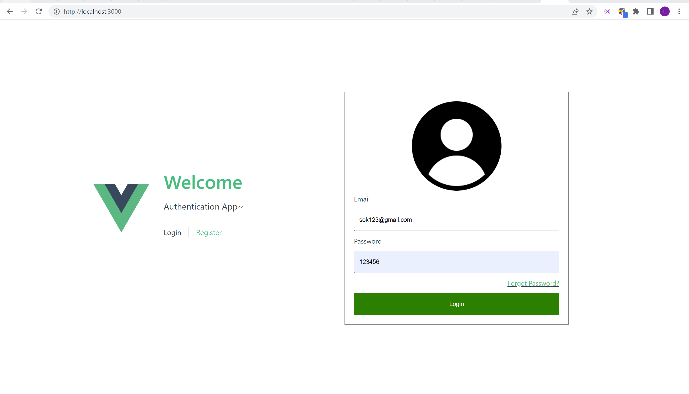

* It will route to home page after a success login

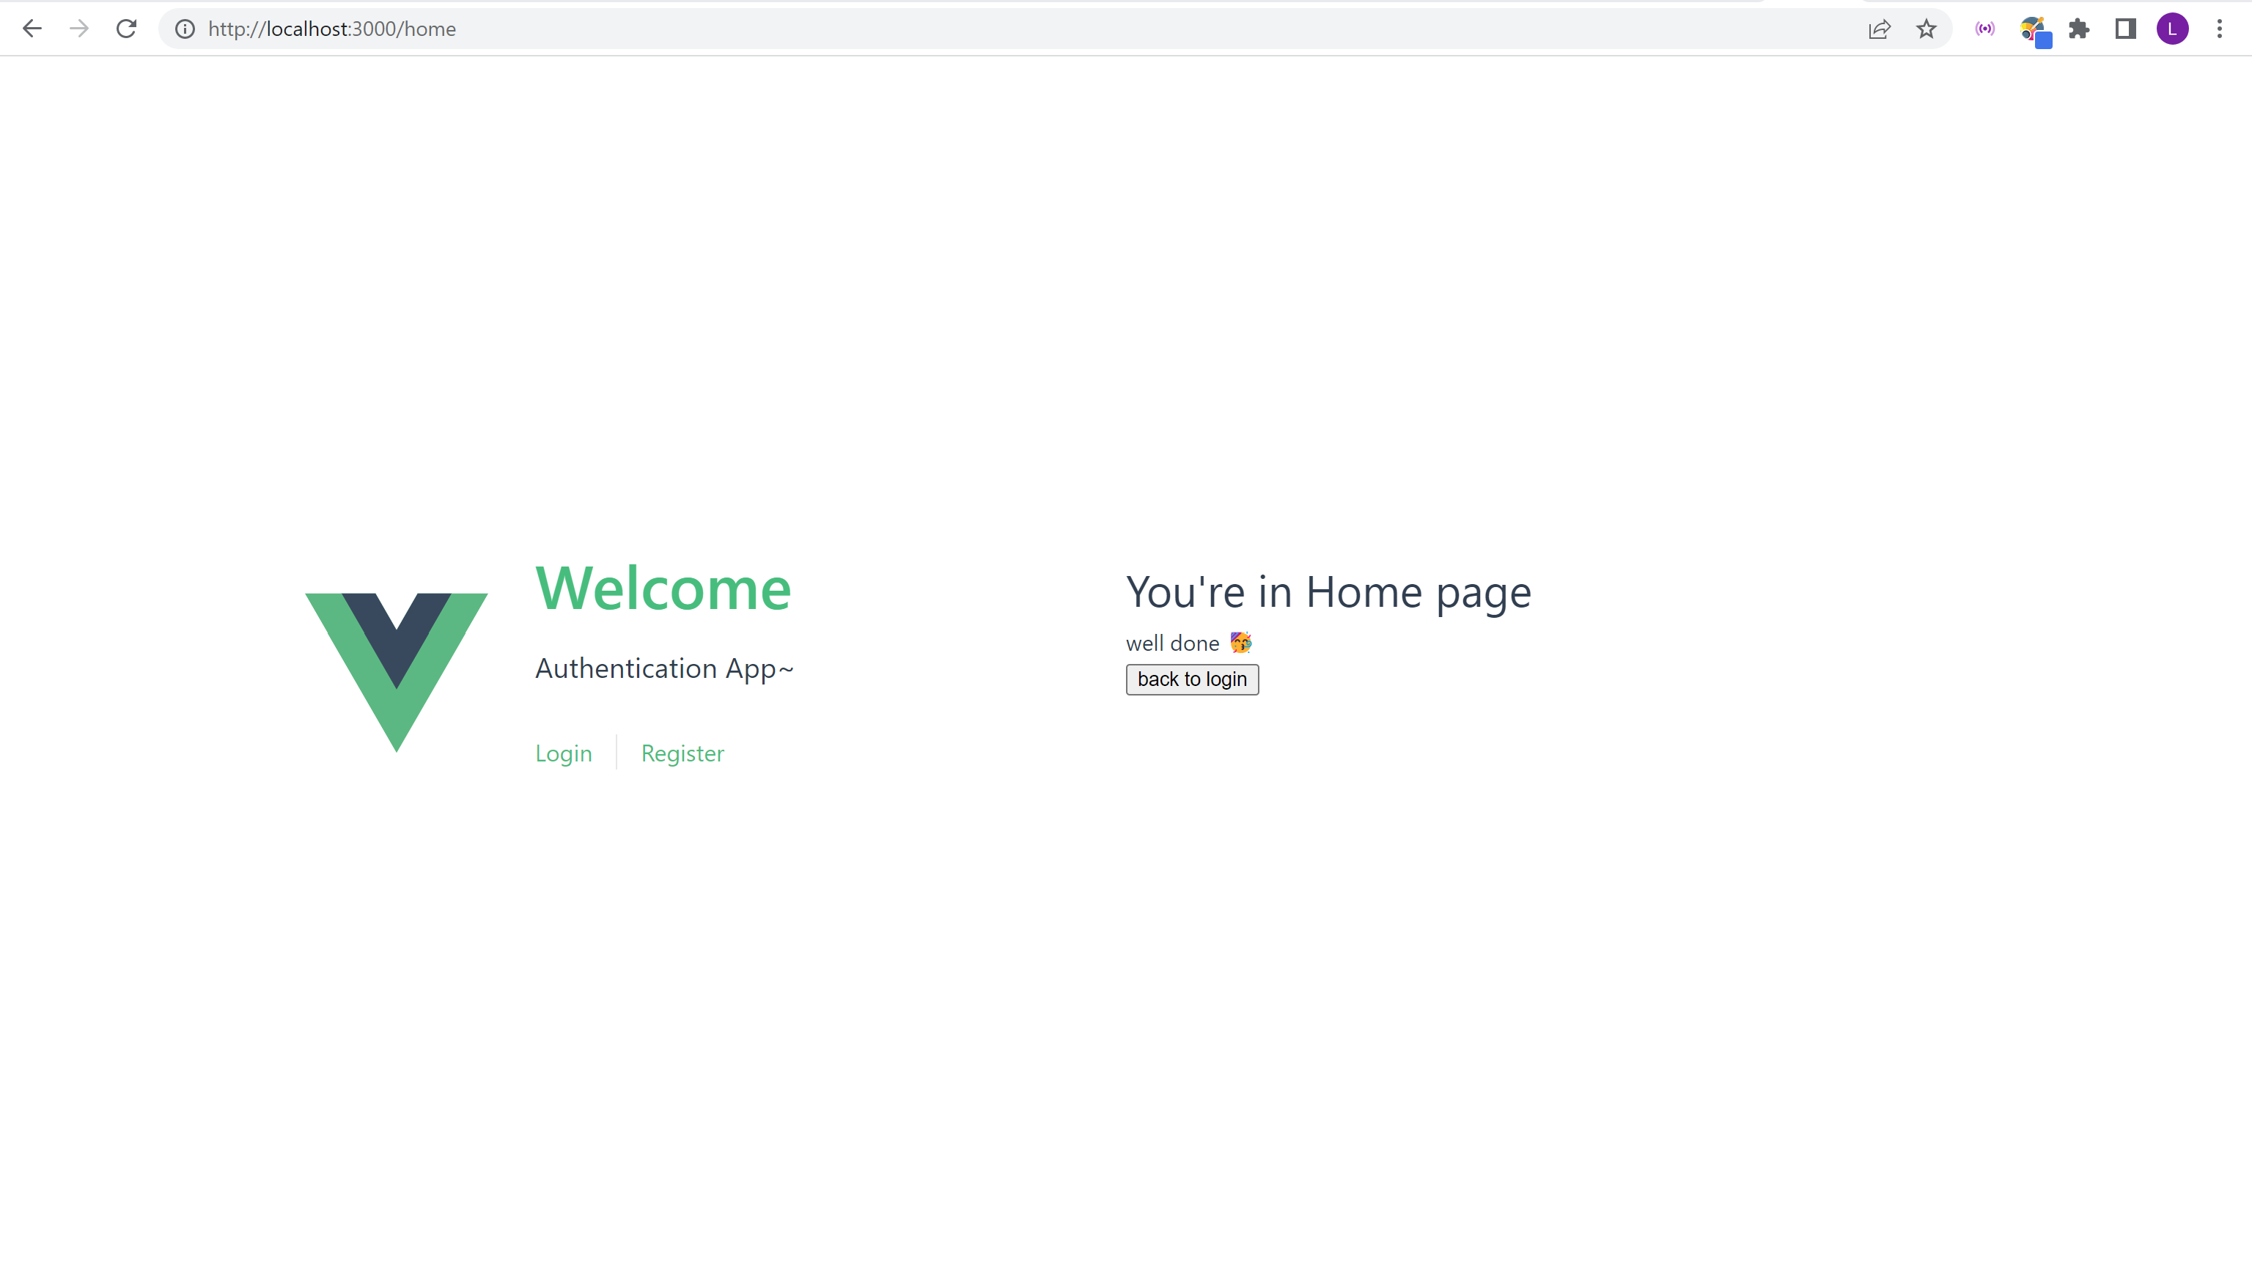

# EX2 – add more API to node project (me, update password, user, delete)

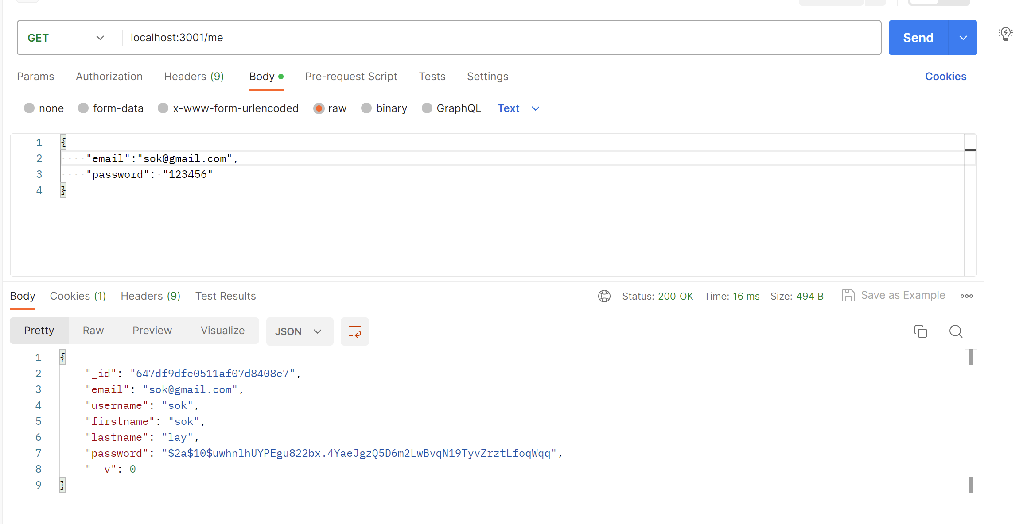

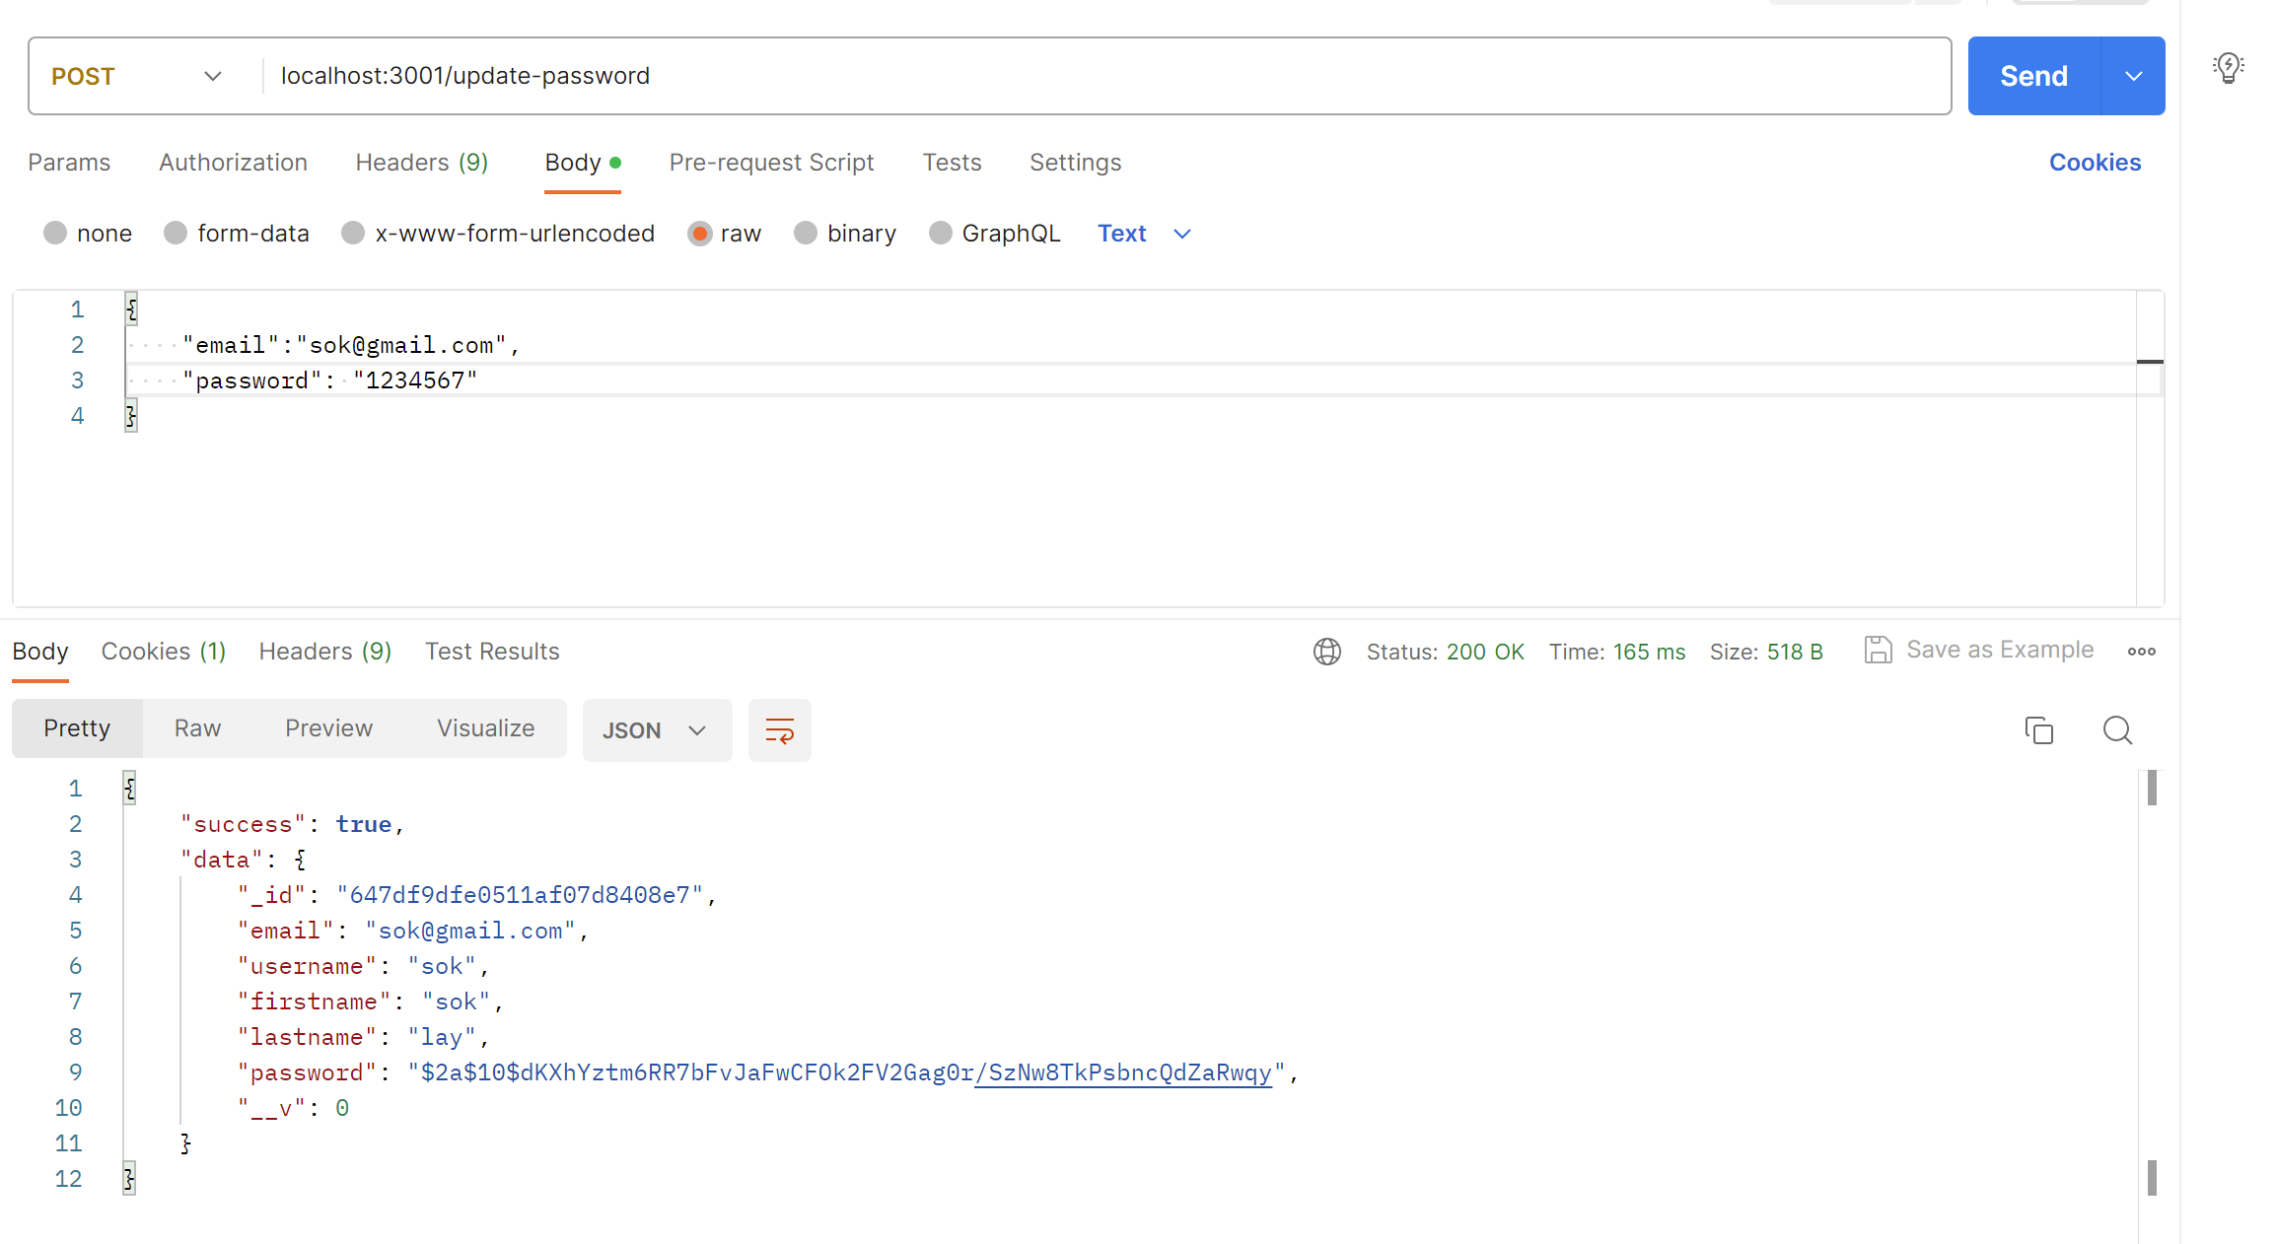

* After update the user’s password



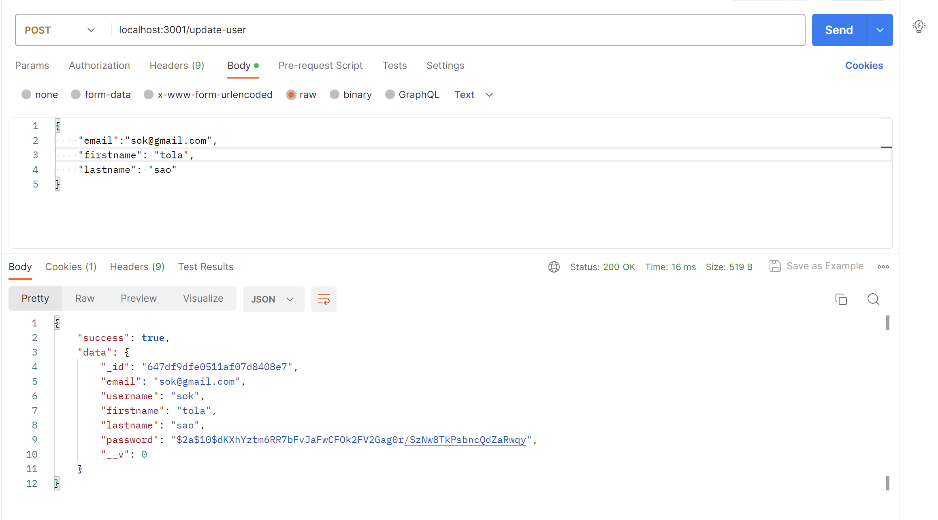

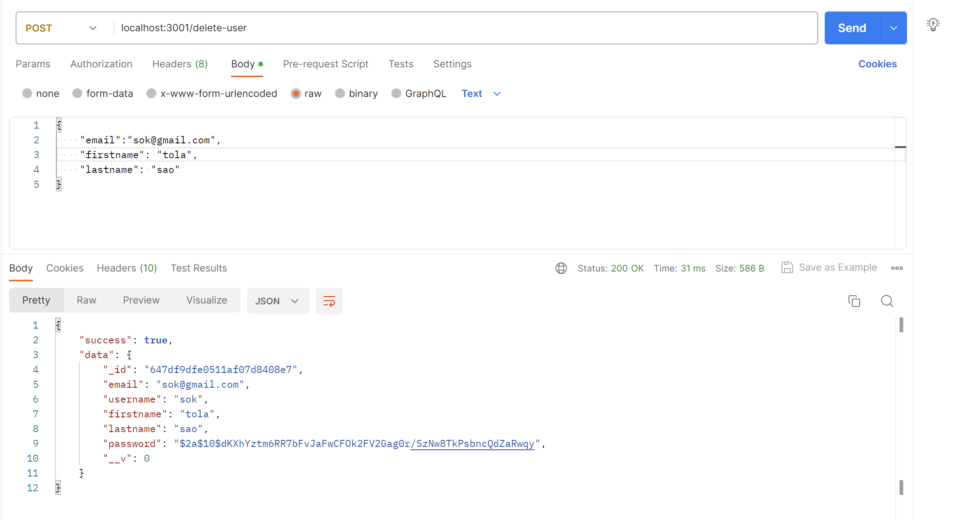

* After delete the user

